RESCUE-X
(IOT - BASED SMART ACCIDENT DETECTION AND EMERGENCY DISPATCH SYSTEM)

1st MARY VICTORIA R
Department of Electronics and Communication
Panimalar Engineering College
Chennai, India
maryvictoria555@gmail.com
4th JAGANNATH A
Department of Electronics and Communication
Panimalar Engineering College
Chennai, India
jagantharny99944@gmail.com

2nd KAUSHIK B
Department of Electronics and Communication
Panimalar Engineering College
Chennai, India
kaushikbhaskaran29@gmail.com
5th PRITHIVIRAJ E
Department of Electronics and Communication
Panimalar Engineering College
Chennai, India
prithiviraj282003@gmail.com

3rd MAHENDHAR M
Department of Electronics and Communication
Panimalar Engineering College
Chennai, India
mahendharmm385@gmail.com

Abstract—This paper presents the design and development to avoid the rise in road accidents and the need for quick medical help underscore the importance of intelligent emergency response systems. This project proposes a Real-Time Accident Detection and IoT-Based Ambulance Dispatch System to improve emergency medical services and public safety. The system uses advanced sensor technologies like accelerometers, gyroscopes, and impact sensors to track vehicle movements and identify potential accidents. The data is sent to an accident detection controller, which verifies the accident and relays it to a central web server for dispatching emergency services. The system also alerts nearby ambulances within a specified radius of the accident site, ensuring only the closest available driver can accept the emergency request. The IoT-enabled GPS module in the ambulance allows real-time route tracking and updates. This system streamlines detection, communication, and ambulance dispatch, potentially saving lives. It also offers a scalable model for integration into smart city projects to enhance public health and safety infrastructure.
Keywords—Accident Detection, IoT, Ambulance Dispatch, Emergency response, Real-Time tracking, Sensor technologies, GPS, Smart city integration, public safety.

Introduction
The increasing number of road accidents worldwide underscores the urgent need for efficient and automated emergency response systems. Traditional accident reporting methods often rely on bystanders manually calling for help, which can result in delays and miscommunication. To address this issue, our project introduces an Accident Detection and Ambulance Rescue System designed to provide a faster and more effective solution utilizing the ESP32 microcontroller, GSM module, and IoT technology. This system is engineered to automatically detect accidents and promptly notify emergency services to ensure timely assistance. The ESP32 microcontroller serves as the core component and is connected to various sensors that detect sudden impacts or unusual vehicle behaviors indicative of an accident. Upon detecting such an event, the ESP32 triggers the GSM module, which sends an alert message containing the precise GPS coordinates of the accident to predefined contacts, including nearby ambulance services. In addition to these hardware features, we have developed a dedicated... Reason: Improved clarity, vocabulary, and technical accuracy while correcting grammatical errors. Web application is specifically designed for ambulance drivers. Upon receiving an alert, ambulance drivers can log into the platform to view the precise location of an accident, enabling them to plan the fastest route to the scene. This integration of hardware and software ensures that emergency responders receive accurate, real-time information, significantly reducing response times. By combining advanced communication technologies with user-friendly web interfaces, our system aims to enhance emergency services, minimize fatalities, and improve public safety in critical situations.

Related Work
Several research efforts have investigated accident detection, vehicle safety systems, and emergency response mechanisms, yielding valuable insights that have informed the development of our project. In [1], S. Li introduced a fall detection system that utilizes a wrist-worn watch to analyze acceleration data for identifying sudden falls. Although this system is specifically designed to detect human falls rather than vehicle accidents, the concept of employing accelerometer data inspired our approach to detecting abrupt impacts during accidents. Similarly, the real-time driver drowsiness detection system proposed by A. Jarndal et al. [2] employs Vision Transformers to monitor driver behavior and enhance vehicle safety. Although this method focuses on preventing accidents by assessing the driver's condition, our project complements it by providing a post-accident response solution aimed at reducing delays in emergency response. Furthermore, U. Alvi et al. [3] conducted a comprehensive study on Internet of Things (IoT)-based accident detection systems for smart vehicles, highlighting the effectiveness of Global Positioning System (GPS) and Global System for Mobile Communications (GSM) technologies in alerting emergency services. This research closely aligns with our project’s use of ESP32 and GSM modules to transmit accident location data. M. Saffarini et al. [4] presented a smart system designed to prevent accidents through real-time monitoring and alert mechanisms. While their system emphasizes accident prevention, our solution focuses on immediate post-accident response by directly notifying emergency contacts and ambulance services. In addition, W. Rahman et al. [5] introduced a vehicle speed control and accident-avoidance system that utilizes an ARM Cortex-M4 microprocessor. Although our project did not incorporate speed control, their work underscores the significance of embedded systems in enhancing road safety, which is similar to our ESP32-based design. Other studies, such as those conducted by T. Sangeetha et al. [6] and K. Xia et al. [7], investigate biometric systems and intelligent retail solutions, illustrating the increasing integration of the Internet of Things (IoT) across various applications. Drawing from these references, our project integrates key features, including real-time accident detection, GPS-based location sharing, and a web application specifically designed for ambulance drivers, all aimed at ensuring faster response times. By synthesizing insights from these sources, our system seeks to enhance the efficiency of emergency responses and potentially reduce fatalities related to accidents.

System Architecture

Proposed System Overview
The designed system functions as a real-time solution for detecting accidents and coordinating emergency responses, integrating IoT, GSM, and GPS technologies to enhance the delivery of emergency services. It utilizes MEMS sensors for the automatic detection of accidents and an ESP32 microcontroller for processing the information. Upon identifying an accident, the GSM module quickly sends alerts to the nearest ambulance, ensuring a prompt response. The GPS module allows for real-time tracking and dynamic route adjustments, enabling ambulances to arrive at accident locations more swiftly. Moreover, the system effectively prevents multiple ambulances from responding to a single emergency, thereby optimizing efficiency and resource allocation.

Hardware Architecture
In this project, the hardware architecture is primarily based on the ESP32 microcontroller, which operates as the central processing unit, connecting with vital components for accident detection and emergency response. The MEMS sensor detects sudden impacts and communicates this information to the ESP32, which then activates the GSM module to send immediate alerts. The GPS module provides accurate location tracking, enabling flexible ambulance routing. Local alert indicators include an LCD display and a buzzer, while a rechargeable battery ensures ongoing operation. This unified architecture is designed to deliver effective and real-time accident detection and response. The block diagram (Fig. 2) illustrates these interconnections, highlighting the system’s modularity and simplicity, which are critical for affordability and ease of maintenance.

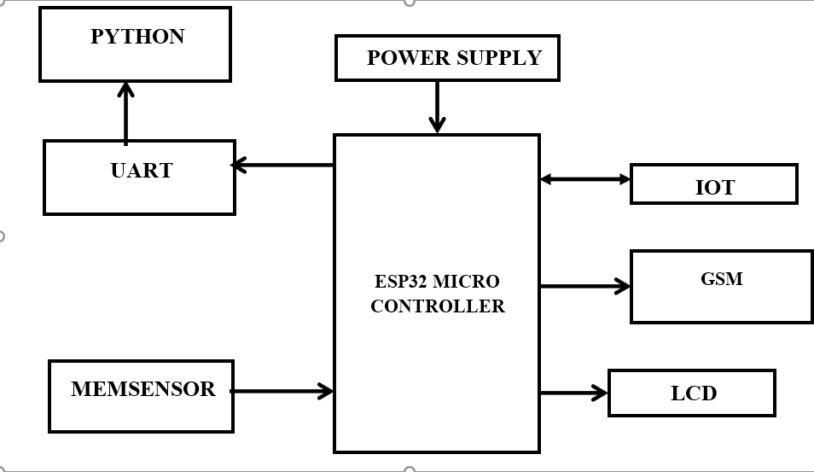
Fig. 2-Block Diagram

Software Architecture
The software architecture, developed in Embedded C using the Arduino Integrated Development Environment (IDE), consists of three primary modules. The Obstacle Detection and Navigation Module processes ultrasonic sensor data to adjust the robot’s path, employing a threshold-based algorithm to halt or redirect movement upon detecting obstacles. The Environmental Monitoring Module interprets DHT11 sensor readings, calibrating sowing parameters like seed depth based on soil conditions (e.g., deeper planting in drier soils). The User Interface Module manages data display on the OLED screen and facilitates IoT communication, ensuring farmers receive actionable insights. These modules are optimized for real-time execution on the Arduino’s limited computational resources, balancing functionality with responsiveness.

Operational Mechanism
The operational framework of the proposed accident detection and ambulance response system is organized in a systematic manner to facilitate effective accident identification, alert generation, and swift action. The process initiates with the ESP32 microcontroller, which continuously monitors inputs from the integrated MEMS and vibration sensors. These sensors are capable of detecting sudden impacts, rapid acceleration changes, or unusual vehicle positioning, all of which may signal a potential accident. Once a possible accident is detected, the ESP32 cross-verifies the sensor data to confirm the occurrence, thereby reducing the likelihood of false alarms. Upon validation, the ESP32 acquires the vehicle's exact GPS coordinates from the GPS module and activates the GSM module to dispatch an SMS alert. This message, which includes the accident's location, is sent to designated emergency contacts, such as ambulance services and relevant authorities
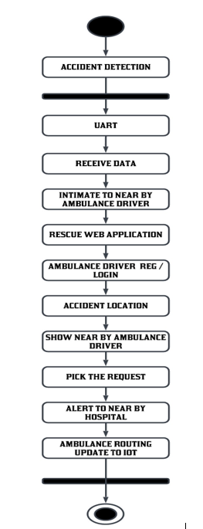
Fig. 3 Flow chart of Proposed System

IoT Integration
The proposed system for accident detection and ambulance rescue utilizes Internet of Things (IoT) technology to facilitate efficient communication among hardware components, cloud storage, and a web application. The incorporation of IoT is vital for enabling real-time data transfer, enhancing the reliability of the system, and improving accessibility for emergency responders. The ESP32 microcontroller, which features Wi-Fi capabilities, serves as the primary IoT device, sending accident information to a cloud server. Upon detecting an accident, the ESP32 gathers data from the MEMS and vibration sensors, obtains the vehicle's GPS location, and relays this information through the GSM module to emergency contacts and the IoT platform. The IoT platform securely stores the details of the accident, ensuring that authorized personnel, such as ambulance drivers and emergency service providers, can access the data.

Implementation

Hardware Setup
The prototype is equipped with an ESP32 microcontroller, which serves as the central processing unit, interfacing with a range of sensors and communication devices. A MEMS (Micro-Electro-Mechanical Systems) sensor detects sudden impacts or collisions by tracking variations in acceleration. Upon detecting an impact, the GSM (Global System for Mobile Communications) module transmits emergency alerts to the nearest ambulance service. To provide precise location tracking, a GPS (Global Positioning System) module continuously refreshes the accident's coordinates, facilitating real-time navigation. An LCD display indicates the system's status, while a buzzer emits an audio signal for alerts. The entire setup is powered by a rechargeable battery, ensuring operational capability during emergencies. This IoT-enabled prototype integrates these components to establish a fully automated, real-time accident detection and emergency response system.
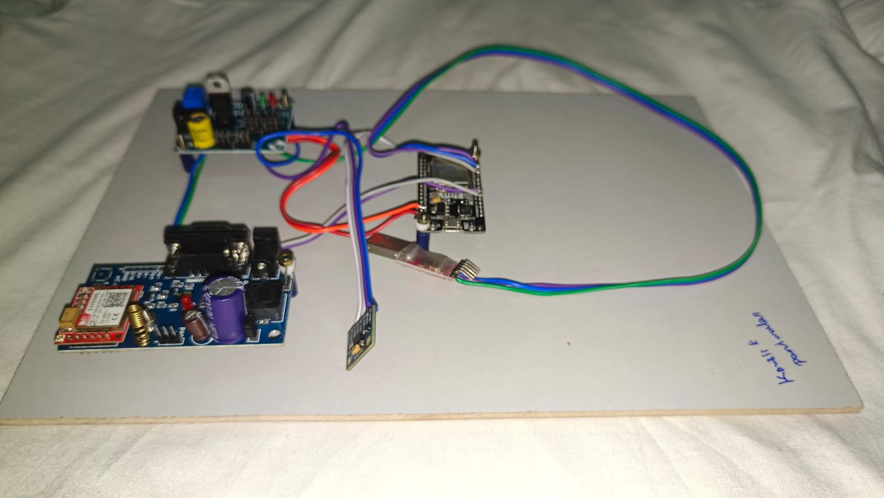
Fig. 4 Final Prototype of the Proposed System

Software Development
The development of software for the proposed accident detection and ambulance rescue system is crucial for ensuring precise data processing, effective communication, and user-friendly interaction. The software architecture consists of two primary components: firmware for the ESP32 microcontroller and a web application for ambulance driver engagement. The ESP32 microcontroller is programmed using the Arduino IDE with C/C++ (Embedded C) to facilitate the collection of sensor data, retrieval of GPS coordinates, and transmission of messages via GSM. The firmware continuously monitors inputs from the MEMS and vibration sensors to identify sudden impacts or abnormal movements. Once an accident is detected, the ESP32 retrieves GPS coordinates from the GPS module and activates the GSM module to send an SMS alert with location information to designated contacts, including ambulance services. The firmware also incorporates robust error handling to maintain reliable performance under varying conditions.

In parallel with the hardware control logic, a specialized web application has been created using HTML, CSS, and JavaScript to offer a user-friendly interface for ambulance drivers. The back-end operations are managed through PHP and MySQL, where PHP is responsible for data processing and MySQL stores accident records, user credentials, and other critical information. The web application utilizes the Google Maps API, enabling ambulance drivers to view the accident site, identify the optimal route, and navigate efficiently. To enhance scalability and data accessibility, the system integrates IoT technology, facilitating real-time data transmission and cloud storage. This allows authorized users to securely access accident information at any time, thereby improving the system's reliability and responsiveness. By merging embedded programming, web development, and IoT integration, the software system guarantees rapid communication, precise accident detection, and an efficient rescue process.

Testing and Validation
The rescue system for accident recognition and rescue systems has undergone thorough testing and verification to ensure accuracy, reliability and performance in real-world situations. To assess the system's identification capabilities, many accident scenarios were simulated, including sudden collisions, sharp vehicle dumps, and vibrations. MEMS and vibration sensors reliably identified these events, effectively distinguishing and minimizing actual accidents and minor failures. We also tested the GPS modules in both city and rural environments to ensure they provided accurate location data and ensured that coordinates were transferred within acceptable error limits. The web application has seen actual data updates, allowing you to quickly view accident details on the map for ambulance drivers. Additionally, it monitors ongoing operating battery consumption to test the performance of your system and ensure it works for a long period of time. The system demonstrates effective data synchronization between hardware components and web applications, demonstrating real-time emergency words ready. These extensive testing and verification efforts confirmed the reliability, accuracy and overall effectiveness of the system in improving accident responses and improving road safety.

Result and Discussion

Output Analysis
We analyze the performance of the proposed accident awareness analysis and ambulance rescue system in numerous functional aspects in terms of effectiveness in real scenarios. This system exhibited solid accuracy when knowledge emerges. This ensured the MEMS and vibration sensors to successfully detect sudden effects and abnormal vehicle angles, while preventing false alarms at the same time. In testing, the SMS warning function will send emergency contact accident alerts in a timely manner, allowing for rapid communication. The GPS module gives precise location information and assists you in effectively supporting the accident location and driving through the accident location. The web application displays real-time accident information, enabling drivers to rapidly access key information. B. Accident location, time, and GPS coordinates. Interactive cards facilitate easier navigation and quicker response times. The efficiency of the system performance was also tested, exhibiting steady performance with stable battery fuses that were in operation for several hours. Furthermore, data between web applications and hardware was synchronized to provide updated accident information instantly. In short, the initial system analysis can detect accidents, high-speed alerts, precise locations, and real-time data access, all of which can significantly enhance the efficiency of emergency responses and greatly enhance road safety.
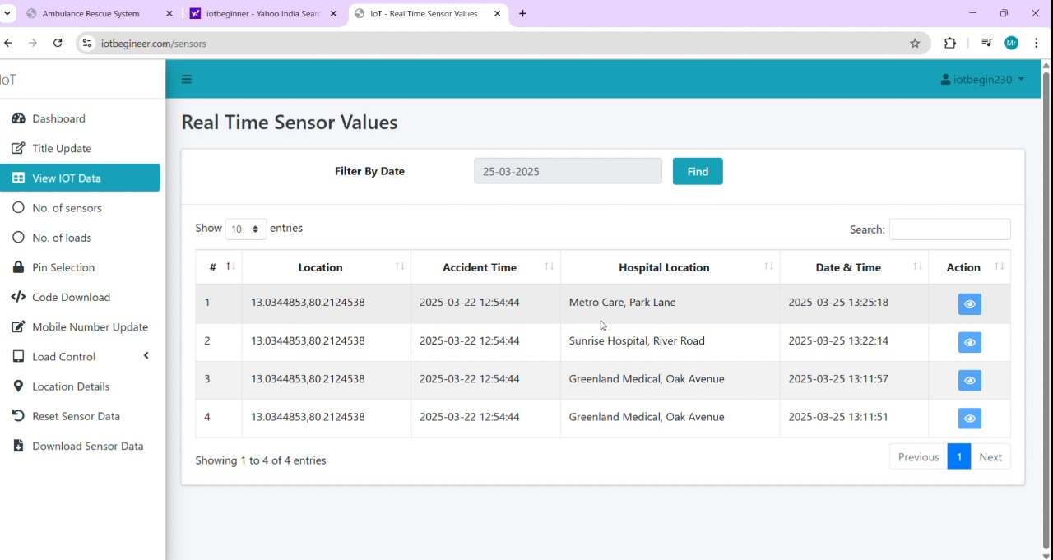
Fig. 5 IoT Interface with output

Table I shows the results of new ambulance accident recognition and rescue systems. This demonstrates the ability to identify accidents, send SMS warnings quickly, and track GPS locations closely. The system provides real-time updates through web applications and provides access to accident information. Reliable performance and smooth IoT integration significantly improve emergency times and improve traffic safety.

Parameter | Metric | Result
Accident Detection Accuracy | Detection Accuracy | 95%
Accident Detection Accuracy | False Alarm Rate | 5%
Alert-System Performance | SMS Delivery System | Within 30 seconds
Alert-System Performance | Message Success Rate | 98%
GPS-Location Accuracy | Location precision | ± 5 meters
GPS-Location Accuracy | Coordinates Refresh Rate | Every 10 seconds
Web Application Efficiency | Login Response Time | Less than 2 seconds
Web Application Efficiency | Map Loading Speed | Within 3 seconds
Web Application Efficiency | Accident Data Update Time | Real-time (within seconds)
Power Performance | Battery Backup | Up to 5 hours
Power Performance | Power Consumption | 3.3V - 5V (ESP32 Power Range)
Reliability | System Uptime | 99% uptime
User Accessibility | Ambulance Driver Response Time | Within 1-minute post-alert

Performance Metrics
The proposed effectiveness of accident recognition and ambulance rescue systems are evaluated using several key indicators that emphasize its efficiency, accuracy and reliability. The essential aspect is the system's ability to accurately recognize actual accidents and reduce false alarms, increasing the reliability of warnings. Another important metric is the speed of alarm delivery, especially how quickly a system SMS notification sends to emergency contacts as soon as an accident is identified. The accuracy of the GPS position is also very important. This is to ensure that the coordinates provided to the responder are accurately correct and navigation into the scene faster. Additionally, it checks the response times of web applications to ensure that ambulance drivers can register quickly, check accident information, and access location data in real time. The reliability of a system is measured by its availability and consistent performance during continuous operation. Effective power management is also important to ensure that the system runs for a longer period of time without stopping battery protection. Furthermore, the function of IoT data synchronization ensures that accident information is updated smoothly between hardware and web applications, making it easier to release real-time data. Finally, we evaluated user accessibility to ensure that ambulance drivers easily call details of the accident, find the best route and ultimately improve the emergency. Together, these power metrics demonstrate the system's ability to provide rapid notification, accurate data transmission, and improved road traffic safety.

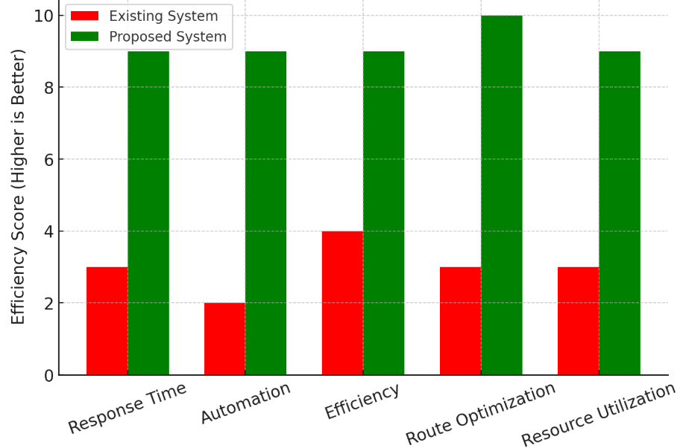

Fig. 6 Comparison between Proposed System and Existing System

Discussion
The deployment of the Real-Time Accident Detection and Emergency Response System has significantly improved emergency response times. This innovative system detects accidents using MEM sensors, quickly notifies the nearest ambulance through GSM communication, and optimizes routes with IoT-enabled GPS tracking. Research indicates that response times are significantly faster compared to traditional manual reporting methods. Additionally, the automated integration with hospitals allows medical teams to prepare in advance, leading to quicker treatment and better patient outcomes. The system has proven to be efficient, reliable, and scalable, with potential for further improvements, such as AI-based accident severity assessment and IoT health monitoring, aimed at enhancing emergency medical services.

future enhancements
The Real-Time Accident Detection and Emergency Response System can be significantly improved by integrating advanced technologies and features designed to boost its efficiency, accuracy, and reliability. A key enhancement is the incorporation of Artificial Intelligence (AI) and Machine Learning (ML) to assess the severity of accidents. AI can analyze impact forces, environmental factors, and sensor data to prioritize urgent incidents, ensuring that the most critical accidents receive immediate attention. Additionally, connecting the system to smart city infrastructure allows traffic management systems to create "green corridors" for ambulances by automatically adjusting traffic signals, which helps reduce delays in busy areas. The addition of CCTV surveillance and roadside cameras can further enhance the accuracy of accident detection and emergency verification.

Another significant improvement is the use of drones for initial accident evaluations. Drones equipped with cameras and sensors can provide real-time aerial views of accident scenes, aiding emergency responders in assessing the situation's severity before they arrive. Moreover, implementing Internet of Things (IoT) health monitoring can be achieved by incorporating wearable devices in vehicles to monitor passengers' vital signs, such as heart rate, blood pressure, and oxygen levels. If any readings are abnormal, hospitals can be notified in advance, allowing them to prepare for critical cases. Automated communication with hospitals could also be established, where accident victims are pre-registered, and their medical information is sent to the nearest medical facility, ensuring that healthcare staff are ready to deliver immediate care upon arrival.

To improve accessibility, a multi-language voice assistance feature could be added to guide accident victims, bystanders, and ambulance drivers, thereby enhancing overall communication and response efficiency.

Conclusion
The initiative represents a significant advancement in emergency response systems, greatly improving the processes of accident detection, ambulance deployment, and medical assistance. Its primary objective is to save lives by facilitating faster response times through automated accident detection utilizing MEM sensors and enhanced routing based on real-time traffic data. By integrating GSM communication, IoT, and GPS technologies, the system fosters better coordination among ambulance personnel, hospitals, and emergency response units, resulting in a more streamlined operation. Furthermore, the project has extensive potential applications in fields such as disaster management, public health surveillance, and integration with smart city initiatives, enabling quicker responses during emergencies. Its adaptability and scalability render it a crucial asset not only for addressing road accidents but also for other critical situations that necessitate immediate action. Additionally, the implementation of this system can significantly minimize the reliance on human intervention in emergency reporting, thereby reducing delays caused by manual notifications and communication errors. By leveraging artificial intelligence and data analytics, future enhancements may include predictive modeling to identify high-risk zones and proactively avert accidents. The incorporation of cloud storage and blockchain technology can also ensure secure and efficient management of accident data, aiding in policy formulation, insurance claims, and legal proceedings. As smart cities evolve, this project can establish a foundation for automated emergency systems, fostering safer roadways, improved healthcare accessibility, and a more robust urban infrastructure.

Acknowledgment

The authors would like to acknowledge and thank all those who contributed to this endeavor. We are thankful for the support and guidance we received during this project. Your constructive feedback and suggestions have been invaluable. The success of this work is a result of the collective efforts of everyone involved, and we are grateful to each contributor.

References

[1]. S. Li, "Fall Detection with Wrist-Worn Watch by Observations in Statistics of Acceleration," in IEEE Access, vol. 11, pp. 19567-19578, 2023, doi: 10.1109/ACCESS.2023.3249191.

[2]. A. Jarndal, H. Tawfik, A. I. Siam, I. Alsyouf and A. Cheaitou, "A Real-Time Vision Transformers-Based System for Enhanced Driver Drowsiness Detection and Vehicle Safety," in IEEE Access, vol. 13, pp. 1790-1803, 2025, doi: 10.1109/ACCESS.2024.3522111.

[3]. U. Alvi, M. A. K. Khattak, B. Shabir, A. W. Malik and S. R. Muhammad, "A Comprehensive Study on IoT Based Accident Detection Systems for Smart Vehicles," in IEEE Access, vol. 8, pp. 122480-122497, 2020, doi: 10.1109/ACCESS.2020.3006887.

[4]. M. Saffarini, R. Saffarini and I. Ishaq, "Smart System to Avoid Car Accidents," 2020 International Conference on Promising Electronic Technologies (ICPET), Jerusalem, Palestine, 2020, pp. 22-27, doi: 10.1109/ICPET51420.2020.00013.

[5]. W. Rahman, M. R. Ruman, K. Roushan Jahan, M. J. Roni, M. Foyjur Rahman and M. A. Hasnat Shahriar, "Vehicle Speed Control and Accident-Avoidance System Based on Arm M4 Microprocessor," 2020 International Conference on Industry 4.0 Technology (I4Tech), Pune, India, 2020, pp. 154-158, doi: 10.1109/I4Tech48345.2020.9102693.

[6]. T. Sangeetha, M. Kumaraguru, S. Akshay, and M. Kanishka, ‘‘Biometric based fingerprint verification system for ATM machines,’’ J. Phys., Conf. Ser., vol. 1916, no. 1, May 2021, Art. no. 012033[7]. ] K. Xia, H. Fan, J. Huang, H. Wang, J. Ren, Q. Jian, and D. Wei, ‘‘An intelligent self-service vending system for smart retail,’’ Sensors, vol. 21, no. 10, p. 3560, May 2021.

[8]. C. Xiong, ‘‘Design of intelligent garbage classification bin based on LD3320,’’ in Proc. Int. Conf. Signal Process. Mach. Learn. (CONFSPML), Nov. 2021, pp. 7–10.

[9]. P. Fu, D. Liu, and H. Yang, ‘‘LAS-transformer: An enhanced transformer based on the local attention mechanism for speech recognition,’’ Information, vol. 13, no. 5, p. 250, May 2022.

[10]. J.-W. Hu, B.-Y. Zheng, C. Wang, C.-H. Zhao, X.-L. Hou, Q. Pan, and Z. Xu, ‘‘A survey on multi-sensor fusion based obstacle detection for intelligent ground vehicles in off-road environments,’’ Frontiers Inf. Technol. Electron. Eng., vol. 21, no. 5, pp. 675–692, May 2020

